**An App for Event Catering and Tiffin Services**

**(RedChillies)**

Developed For

FCAIT, iMSc (IT)

Project Report (SEM – VI)

Submitted For

The Partial Fulfilment Towards

The Degree of

**Integrated Masters of Science (Information Technology)**

**iMSc (IT)**

By

Dhruvi Shah, B41

Laxit Shah, B45

Kush Vachharajani, B66

**Under the Guidance of**

Internal Guide

Prof. Ankita Kanojiya

FCAIT, iMSc(IT),

Ahmedabad



**Faculty of Computer Applications and Information Technology**

**iMSc(IT) Programme, Ahmedabad**

**GLS UNIVERSITY**

Faculty of Computer Applications & Information Technology

***i*MSc(IT) Programme**

**Ahmedabad**

***CERTIFICATE***

This is to certify that

|  |
| --- |
| 1) Laxit Shah  2) Dhruvi Shah  3) Kush Vachharajani |

Student/s of Semester- VI Integrated Msc(IT) [TY iMSc(IT)], FCAIT, GLS University has/have successfully completed the

**Mini Project**

on

“An App For Event Catering And Tiffin Services”

as a partial fulfillment of the study of Third year Semester-VI,

**Integrated Master of Science (Information Technology) [*i*MSc (IT)]**

Date of Submission: ___________________

|  |  |
| --- | --- |
| Prof. Ankita Kanojiya  (Project Guide) | Prof. Tripti Dodiya  (Project Co – ordinator) |

**Acknowledgement**

We would like to express our special thanks to Our Dean Dr. Savita Gandhi as well as our project guide Prof. Ankita Kanojiya who gave us the golden opportunity to do this challenging and wonderful Android Application project on An App for Event Catering and Tiffin Services which is named as Redchilles, which helped us learning a whole new skill set with doing a lot of research and acquiring new skill sets and we are really thankful for that.

**Table of Contents**

|  |  |  |
| --- | --- | --- |
| **Sr No** | **Title** | Page No |
| 1 | Acknowledgement | 3 |
| 2 | Project Profile | 5 |
| 3 | User, Caterer and Admin Functionalities | 6 |
| 4 | Development Tools & Technology Used | 7 |
| 5 | Hardware and Software Requirements | 8 |
| 6 | UML Diagrams | 9 |
| 7 | Data Dictionary | 21 |
| 8 | App Screenshots | 26 |
| 9 | Realtime Database (Firebase) Screenshot | 60 |
| 10 | Admin Panel Screenshots | 61 |
| 11 | Conclusion | 67 |
| 12 | Bibliography | 68 |

**Project Profile**

In our struggling day to day life, we often see that working professional, bachelors, or even couples go to their job very early in the morning leaving no time for them to cook a full meal or a tiffin for themselves especially those who have jobs in tier 2 and tier 3 cities it even becomes more difficult for them to manage this routine.

A simple solution they choose is to order/subscribe a local tiffin vendor who delivers tiffin in their offices but e being a small city and being a small service provider, the tiffin vendor has certain limitations. Also, for the working people it becomes very difficult to trust local cooked food which is unlike their home cooked food and sometimes even they face quality issues like uncooked food or oily food etc apart from that in some cases it also happens that their ordered tiffin doesn’t reach on time or at all.

It has always been a problem that small cities only have a few selected numbers of good restaurants who also provide food delivery services and catering services for any events and if they do so they charge a very high amount for that and also due to that food delivery apps like Swiggy and Zomato also don’t provide their services in small cities that's where RedChilles comes in it is an app for event catering and tiffin service which provides an efficient solution to all these problems. This app follows and promotes a healthy lifestyle, built on a green theme it gives promotes users to follow a healthy lifestyle. Also, the caterers listed here only provide healthy, tasty and freshly prepared meals.

To provide an efficient solution to all these problems we have come up with a solution of making an android app i.e., an App for Event Catering and Tiffin Services which makes this sector an organized one

By this application we can order tiffin from nearby caterers listed already in the app so that user doesn’t have to eat same boring oily food with same taste every day and can get variety from different caterers all around.

Apart from that the app also has the functionality to Organize events by selecting the packages and event types offered by the caterers so that the user doesn’t have to move around finding event organizers in these small cities

Almost 98 per cent of the unorganised catering industry in India is abstained of the inclusive growth, as the caterers were not upgrading their standards until they started facing the brunch of technology, labour rules and rules of conduct of service. So, this app helps these small businesses of caterers to grow giving them a platform to expand and the caterers can improve their services by getting the user rating feedback and apart from that with this app the overall time and extra effort of the user is saved.

**User Functionalities**

* User Registration and Login
* View available Caterers and their details
* View Event and their Packages
* Event Booking
* View Tiffin and their Menu
* User Profile
* Book Tiffin
* Rating

**Caterer Functionalities**

* Caterer Registration and Login
* Add Tiffin and Event Packages
* View added Tiffin and Packages
* Caterer Profile

**Admin Functionalities**

* Cloud Storage of App Data
* Manage Users
* Manage Caterers
* Manage Events
* Manage Tiffin

**Development Tools & Technology Used**

Technology:

Android Studio (Android Integrated Development Environment)

Front End:

Android

Back End:

Firebase (Realtime Database)

**Hardware and Software Requirements**

Hardware Requirements:

Android Device with at least 2GB Ram

Software Requirements:

Minimum Android OS version 4.0 above

**UML Diagrams**

**1 Use Case Diagram**

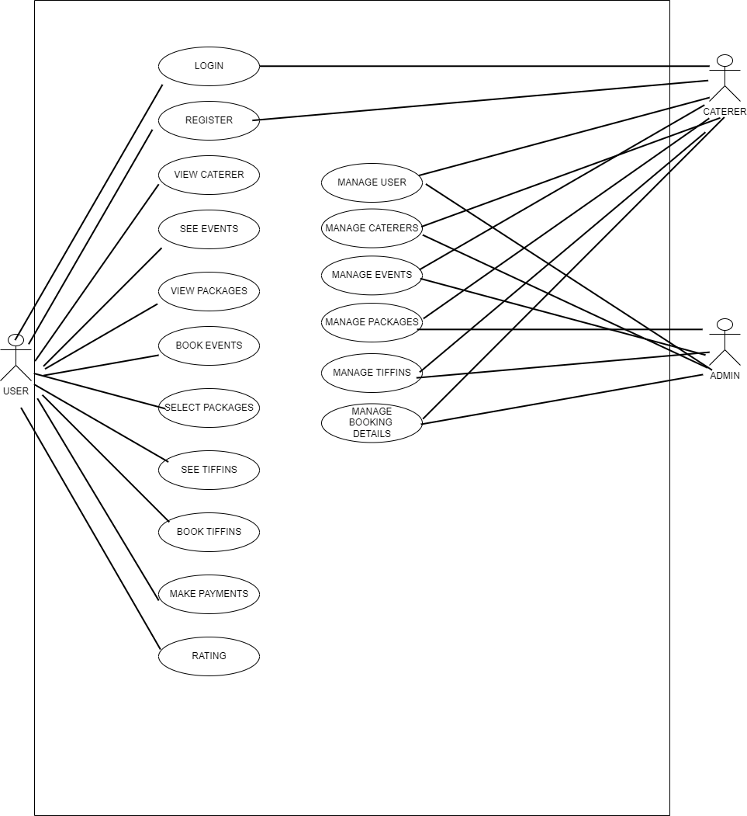

* 1. **Sequence Diagram for Login**

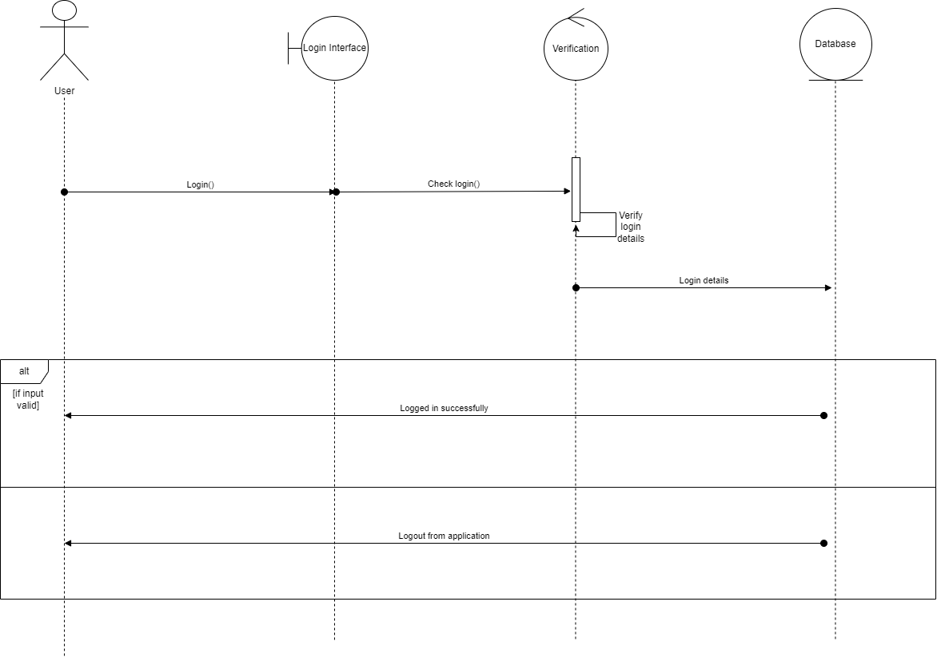

* 1. **Sequence Diagram for Registration**

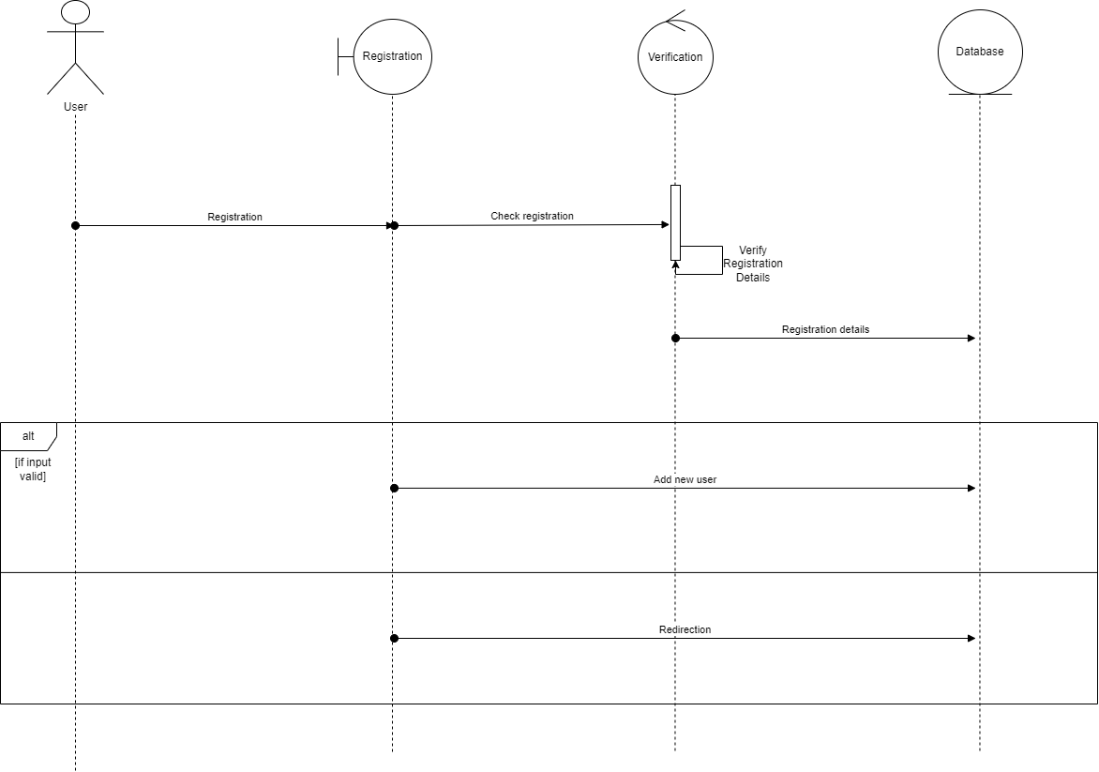

* 1. **Sequence Diagram for Place Tiffin Order**

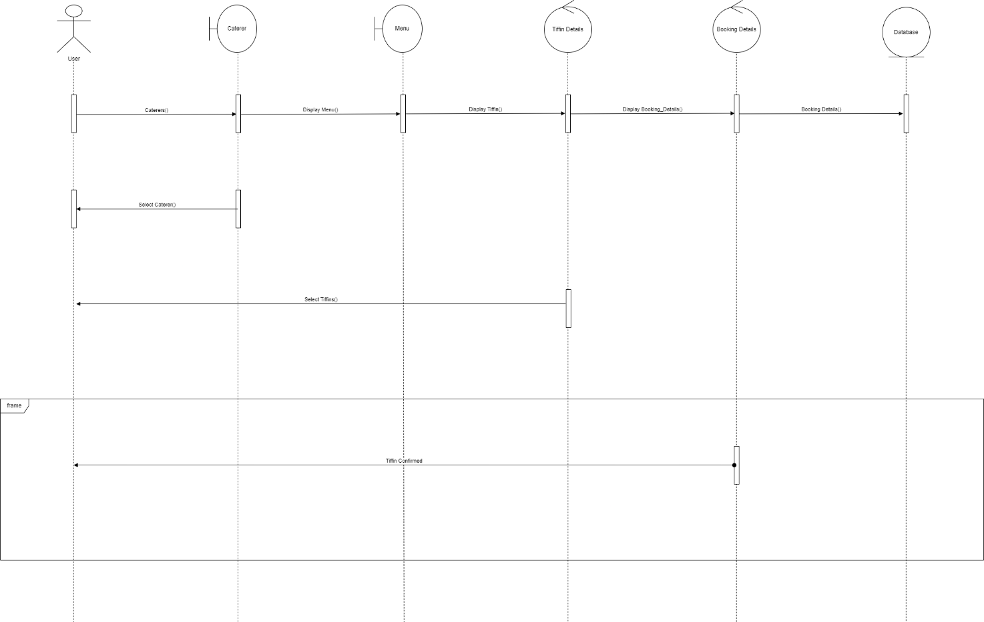

* 1. **Sequence Diagram for Place Event Order**

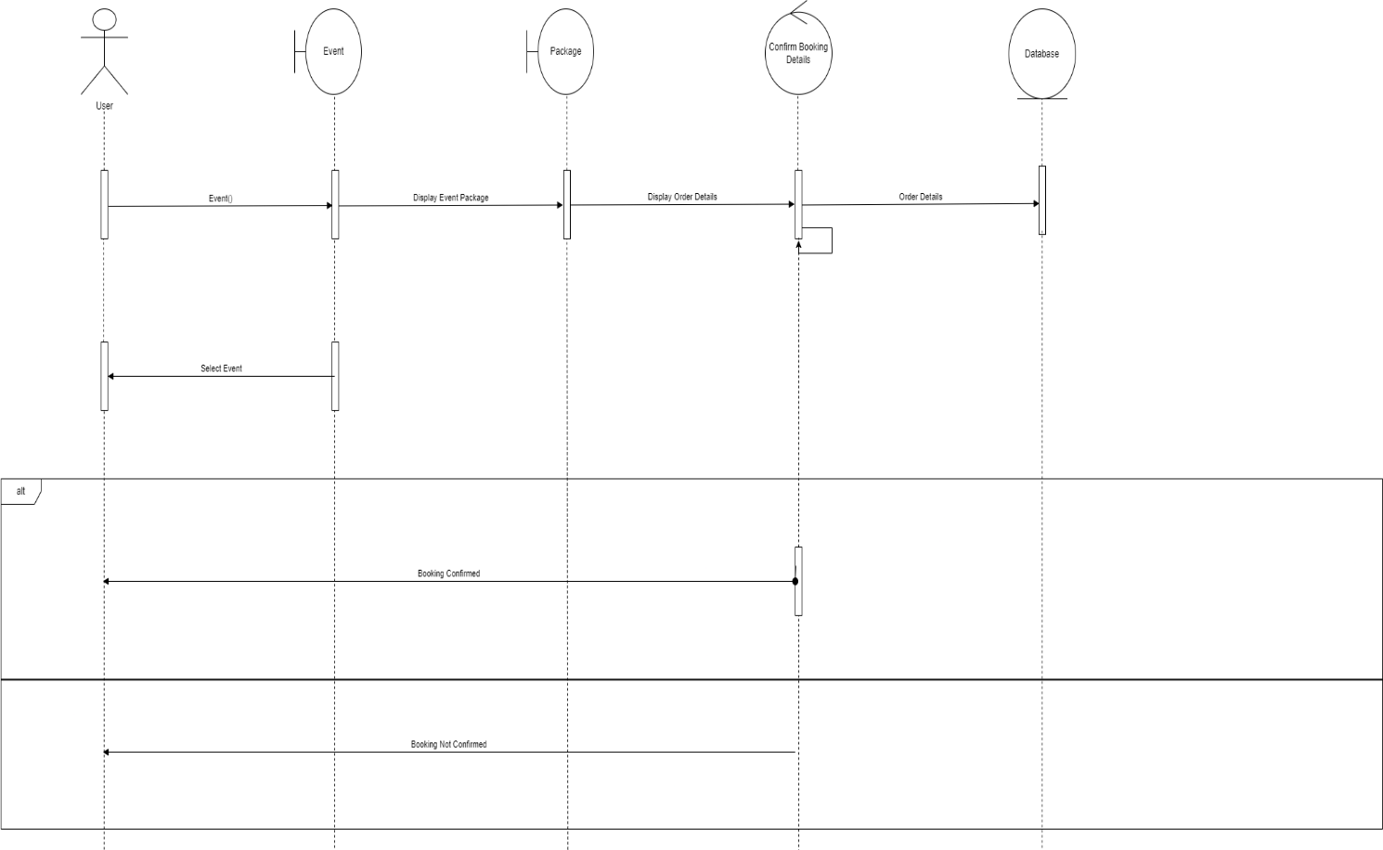

1. **Activity Diagram**

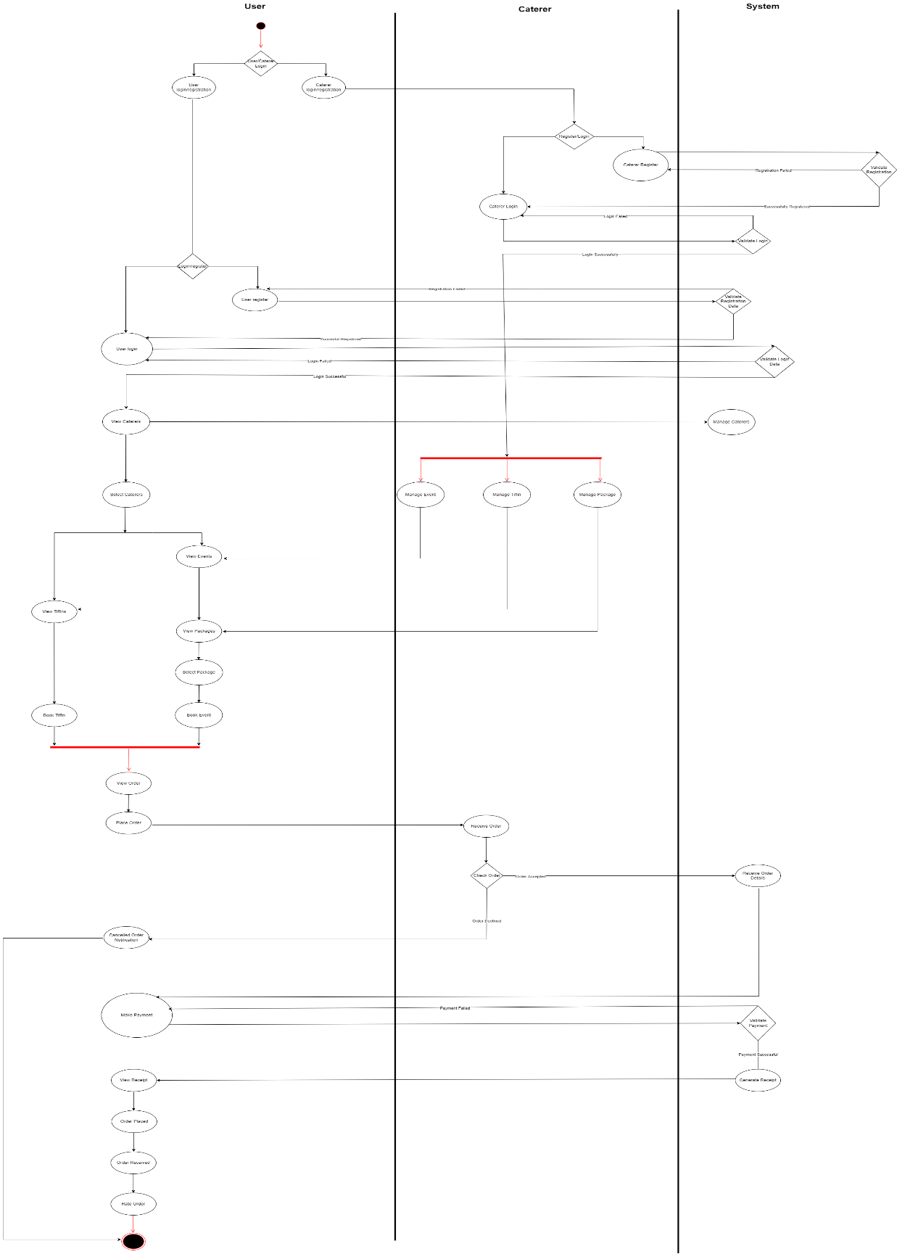

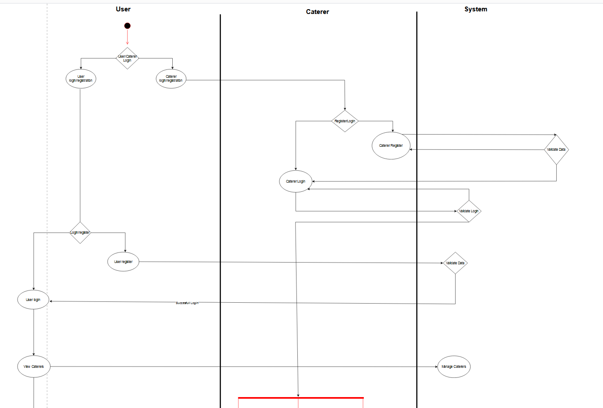

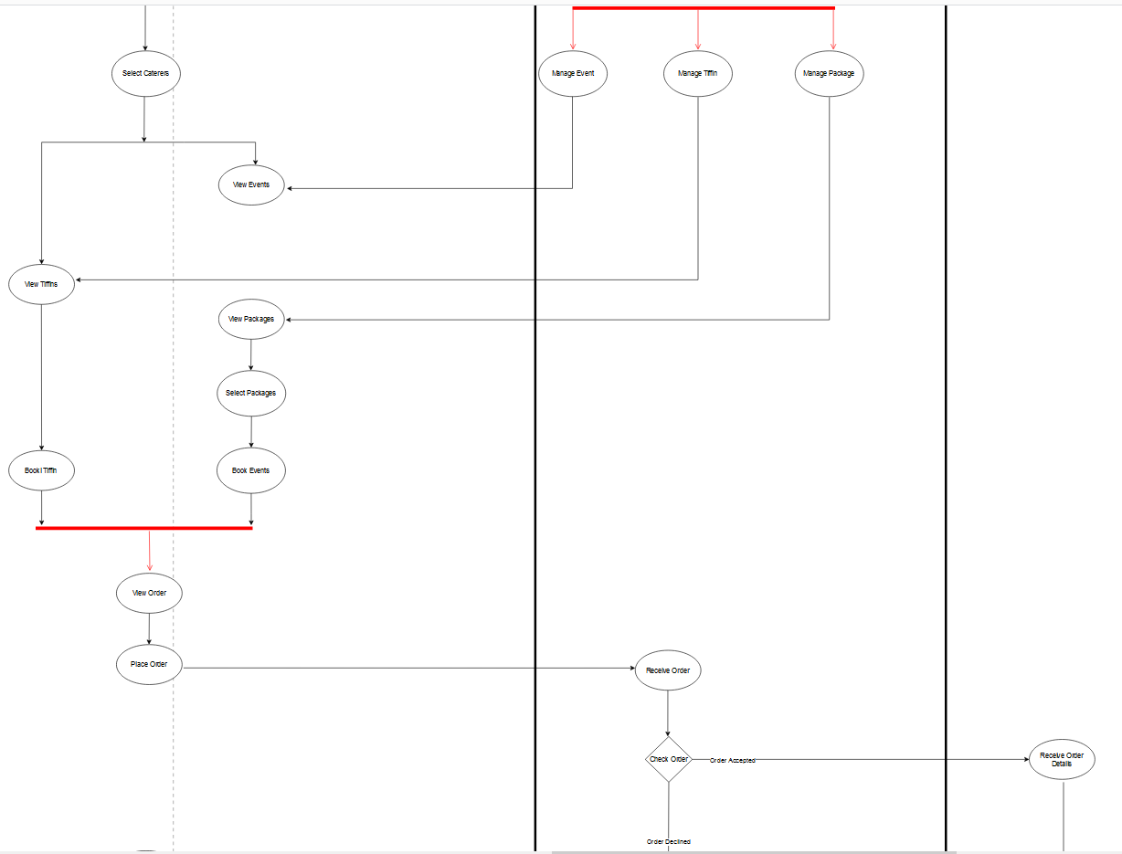

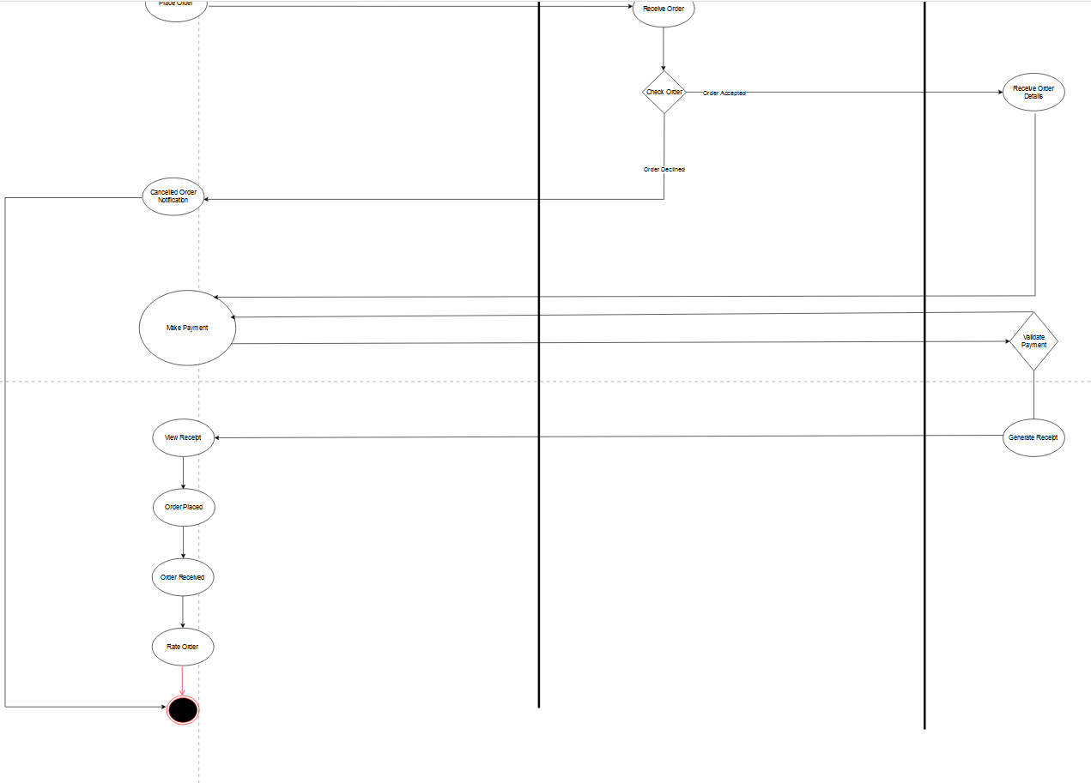

**4.1 State Chart Diagram for Login**

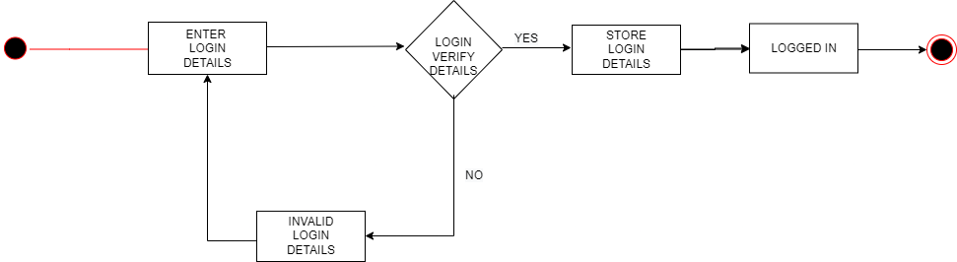

**4.2 State Chart Diagram for Registration**

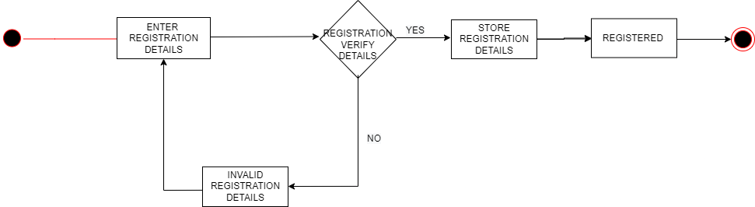

**4.3 State Chart Diagram for Tiffin Booking**

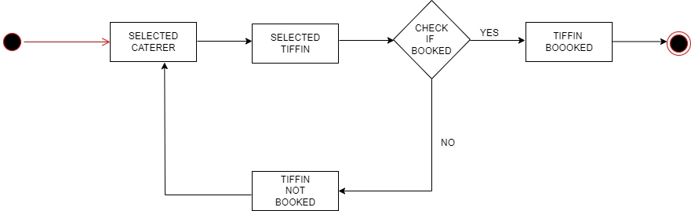

**4.4 State Chart Diagram for Event Booking**

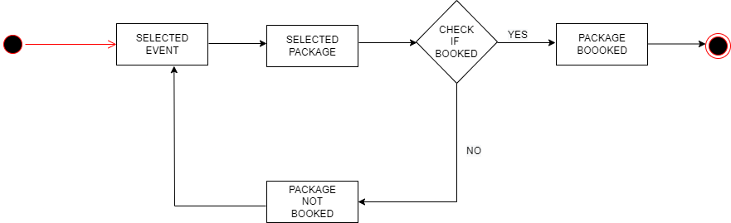

1. **Class Diagram**

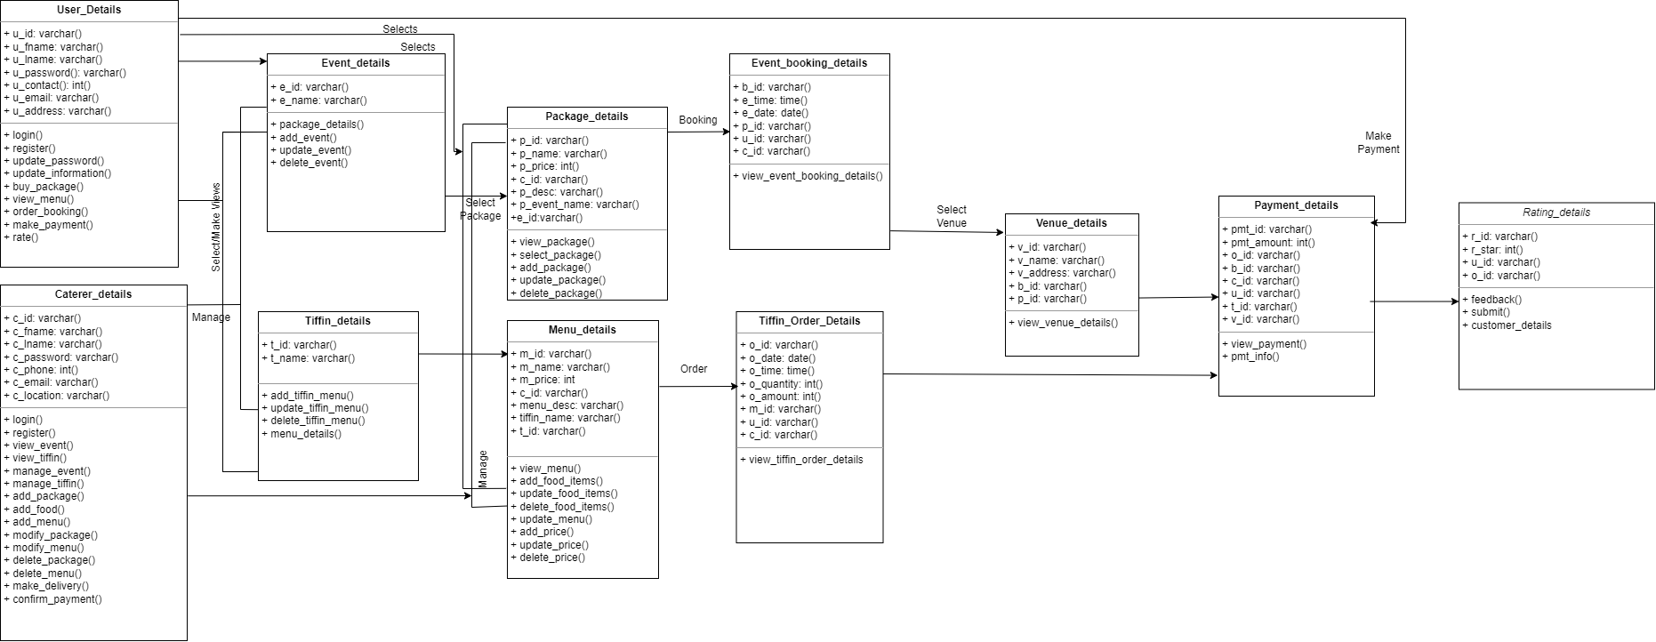

**Data Dictionary Diagrams**

**User_Details**

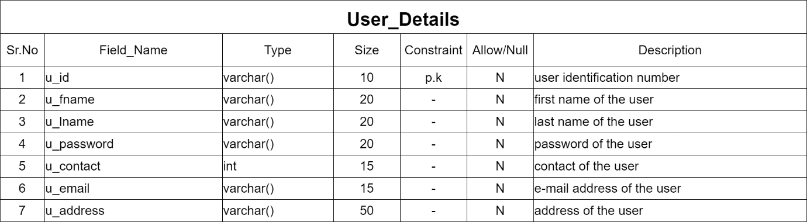

**Caterer_Details**

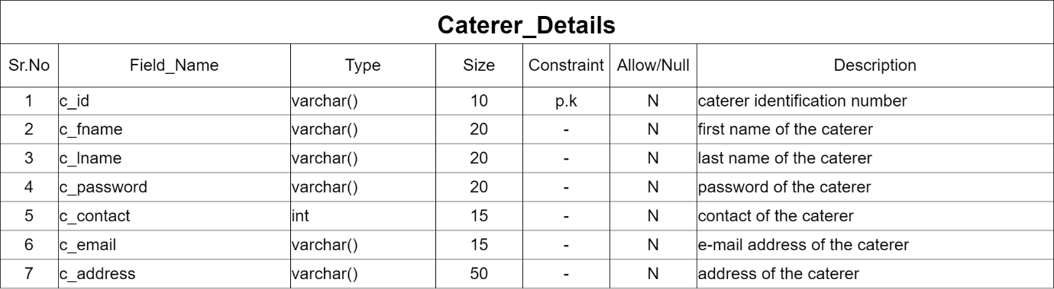

**Tiffin_Details**

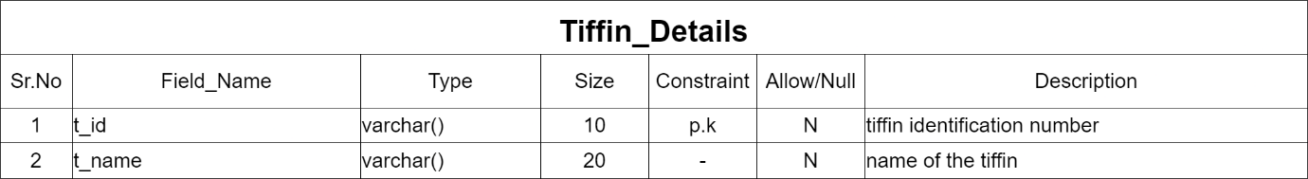

**Tiffin_Order_Details**

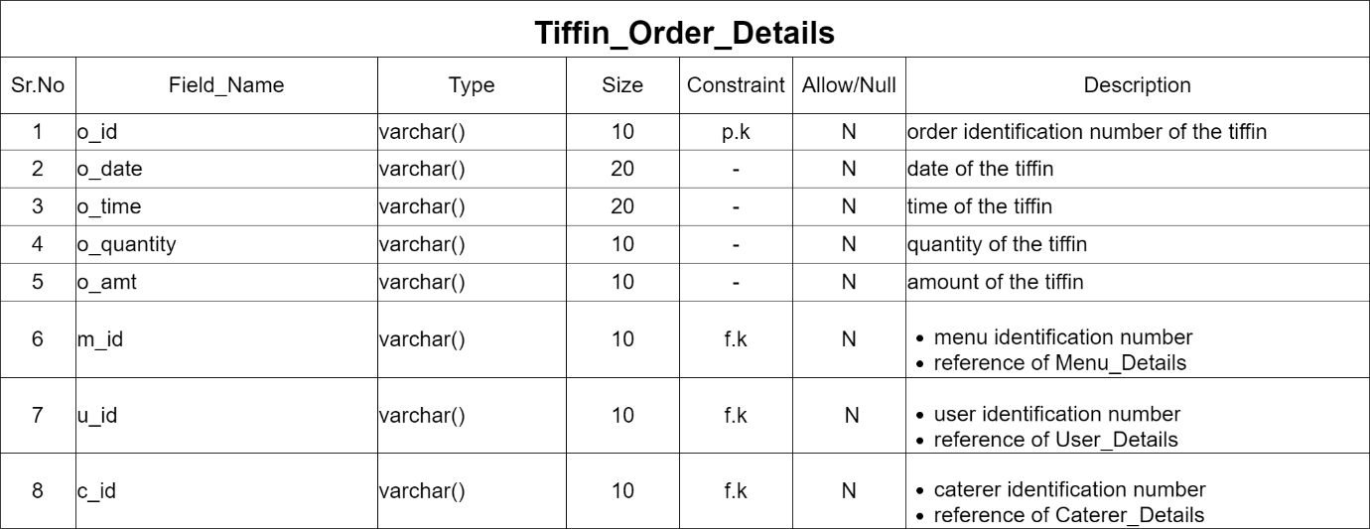

**Menu_Details**

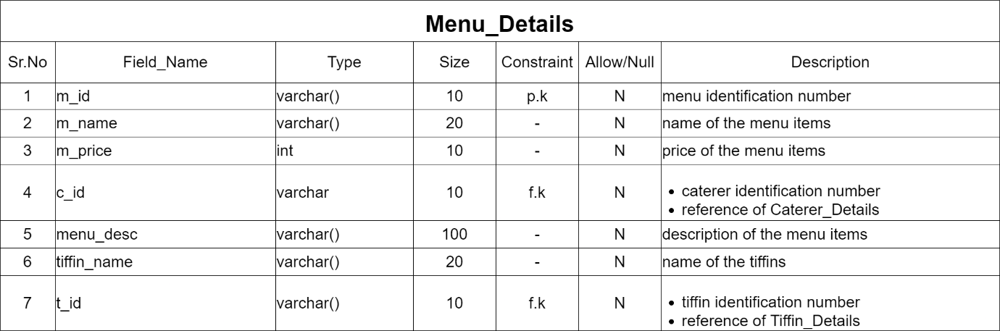

**Package_Details**

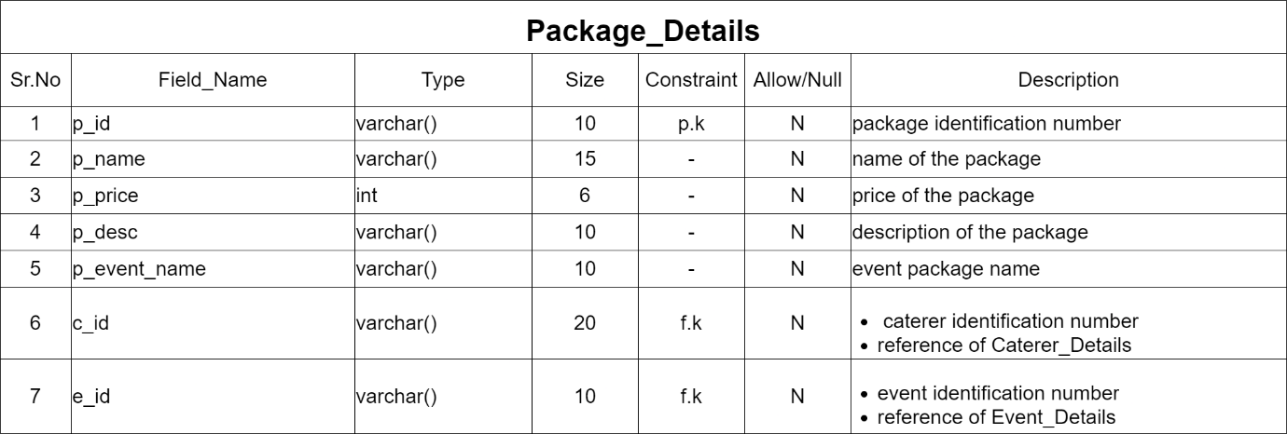

**Event_Details**

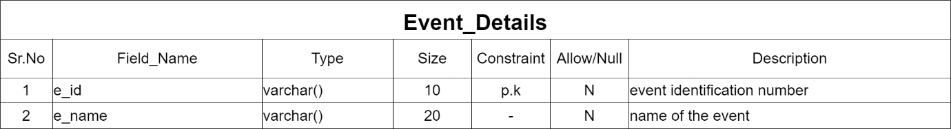

**Event_Booking_Details**

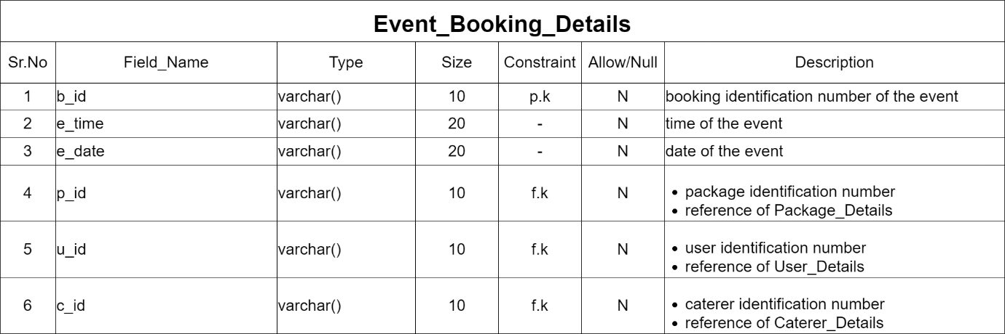

**Venue_Details**

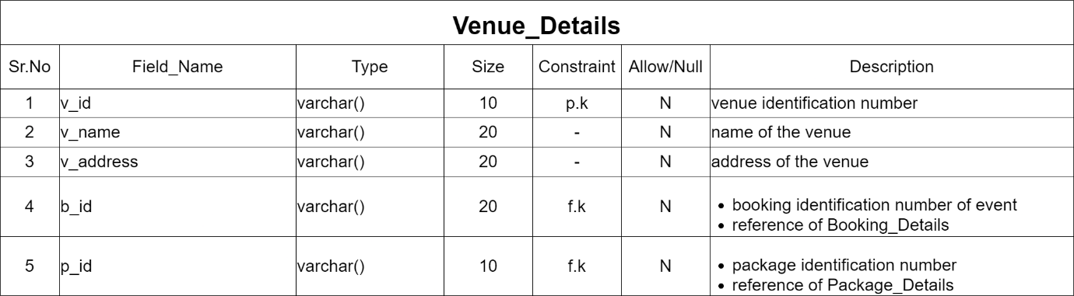

**Payment_Details**

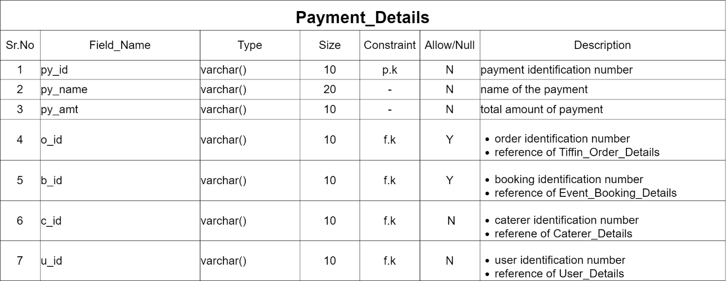

**Rating_Details**

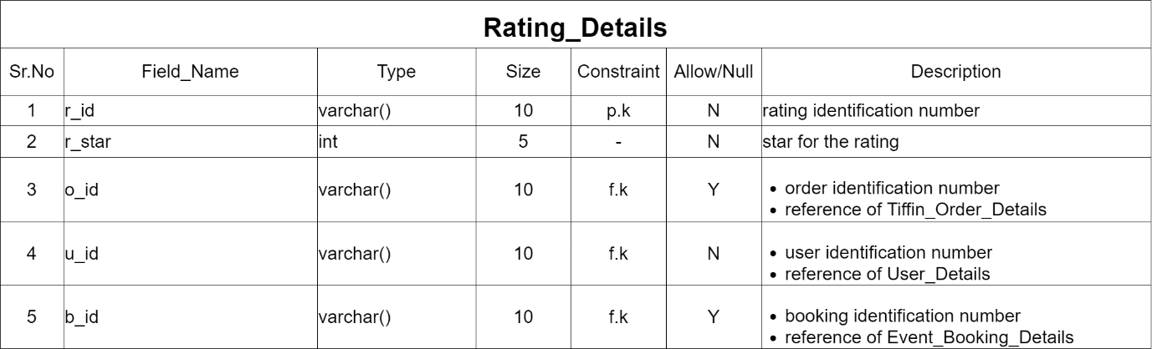

**App Screenshots**

1. **Splash Screen**

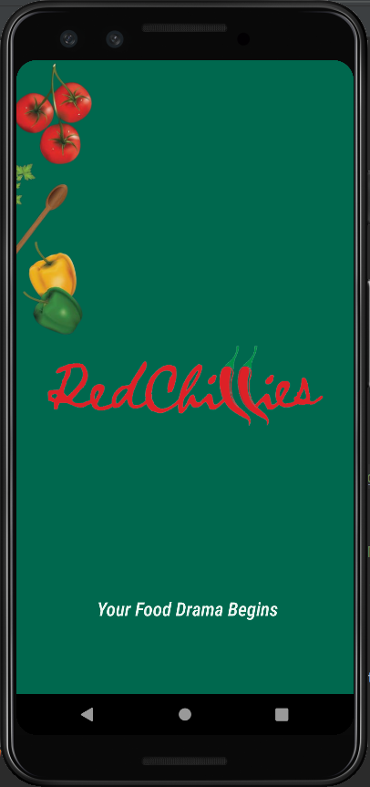

1. **Home Screen**

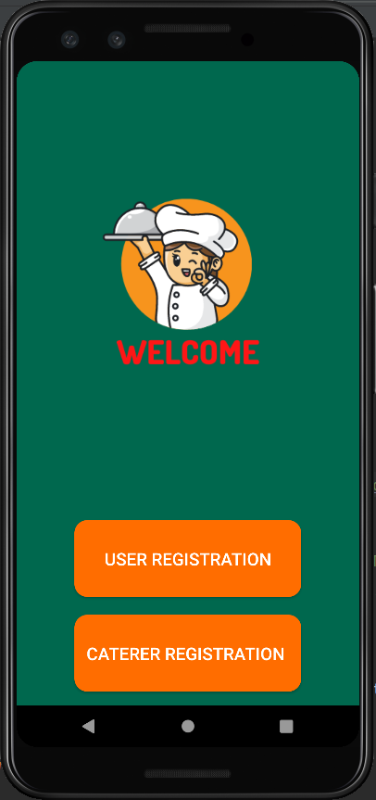

1. **Caterer Registration**

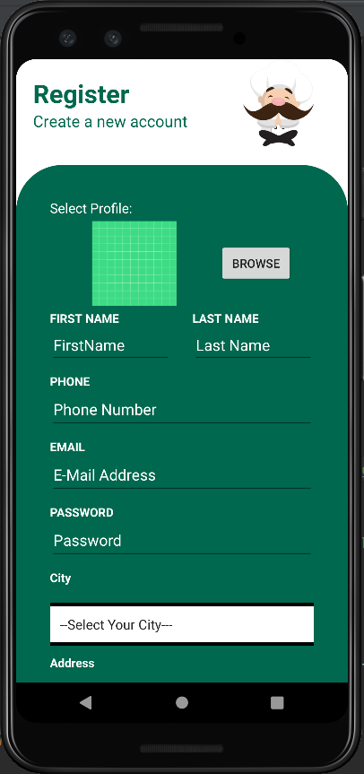

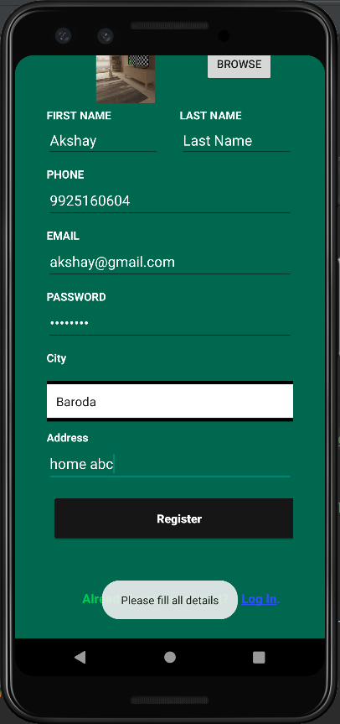

Caterer can register themselves by filling all the details or it will generate a validation error shown in the second screen

1. **Caterer Login**

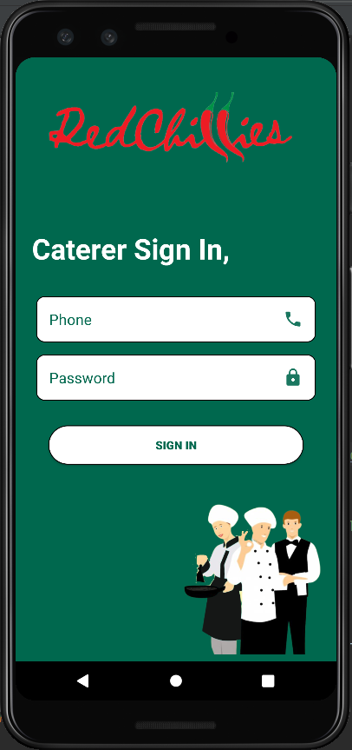

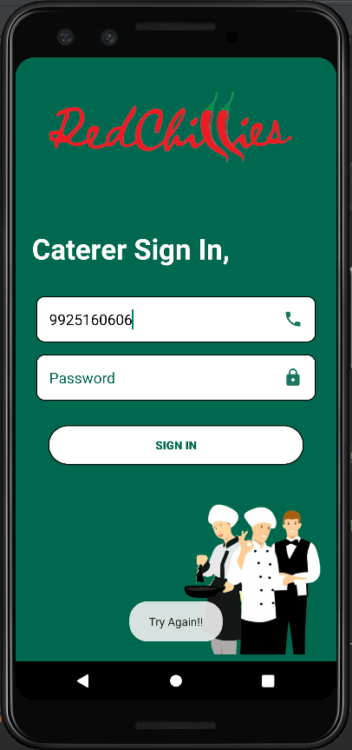

Caterer can login by providing only correct login credentials without leaving the fields blank else it will generate validation error shown in the second screen

1. **Caterer Home Screen**

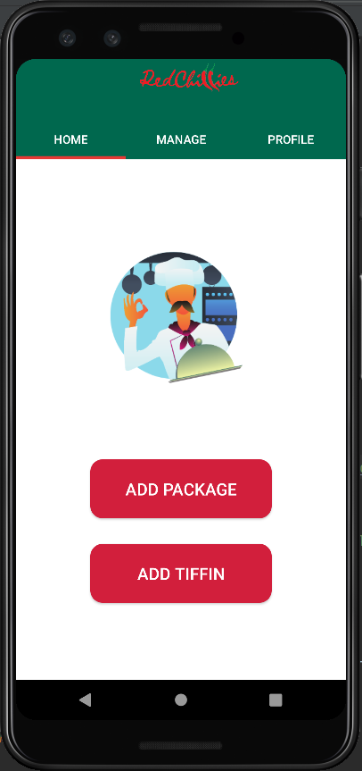

Caterers can easily add packages and add tiffin from the home screen

1. **Caterer Add Package**

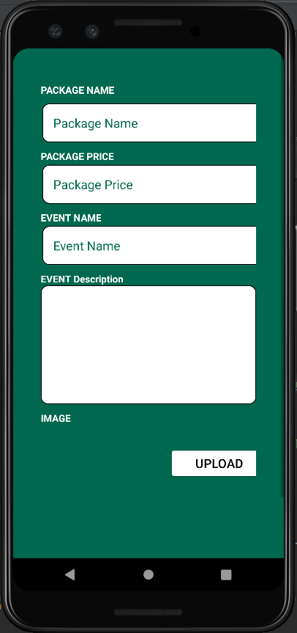

1. **Caterer Add Tiffin**

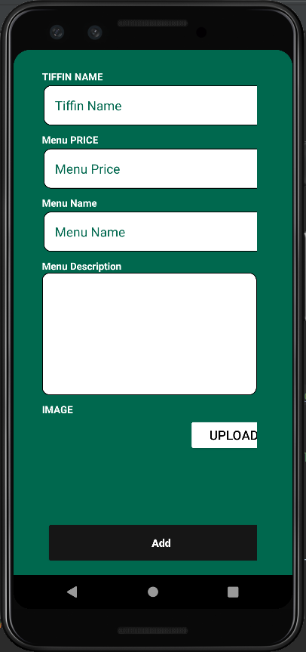

1. **Manage Caterers**

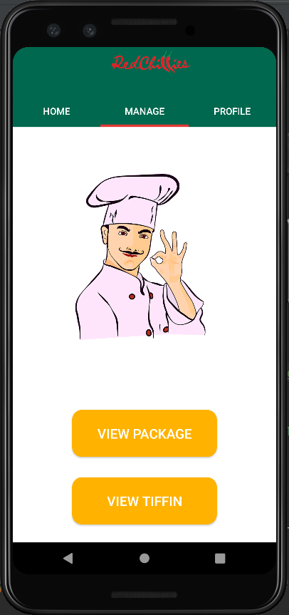

Caterers can view their added tiffin and packages from manage section

1. **Caterer Profile**

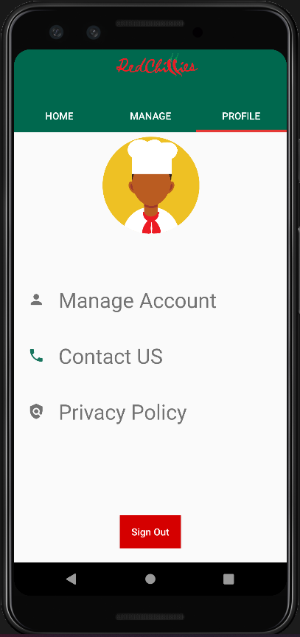

1. **Update Caterer Details**

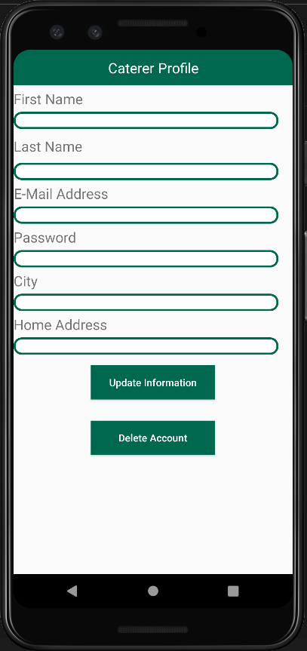

Caterers can update their details by clicking in manage account in their profile

1. **Caterer Sign-out**

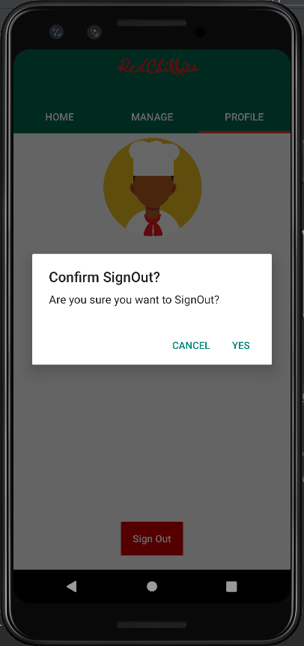

1. **User Registration**

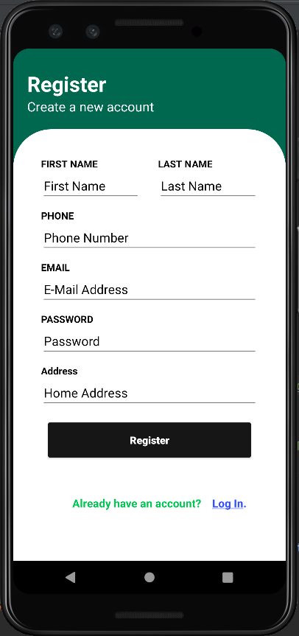

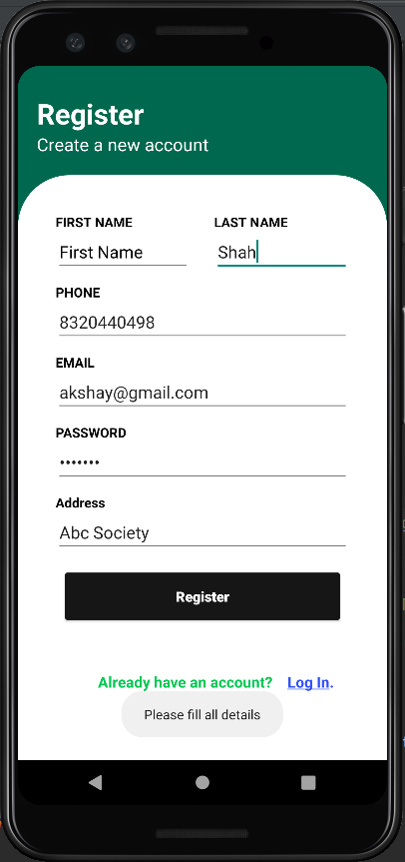

User can register themselves by entering data in all the field else it will generate validation error show in the second screen

1. **User Login**

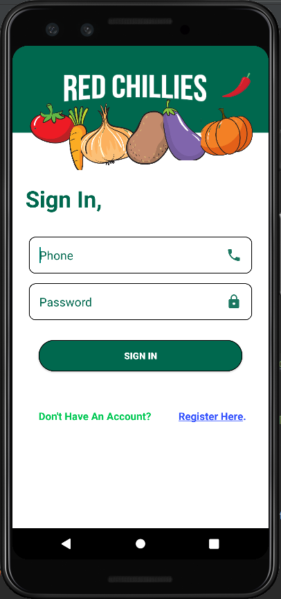

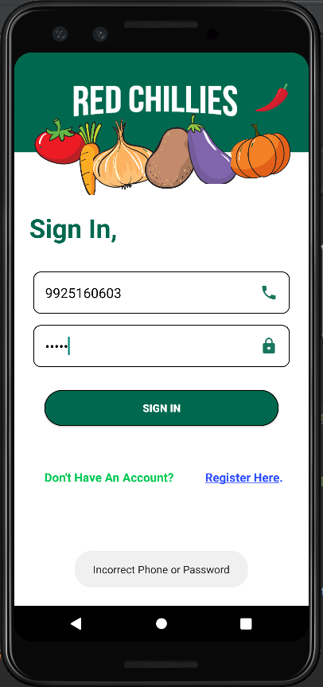

User can only login with correct credentials else it will generate validation error shown in the second screen

1. **User Home Screen**

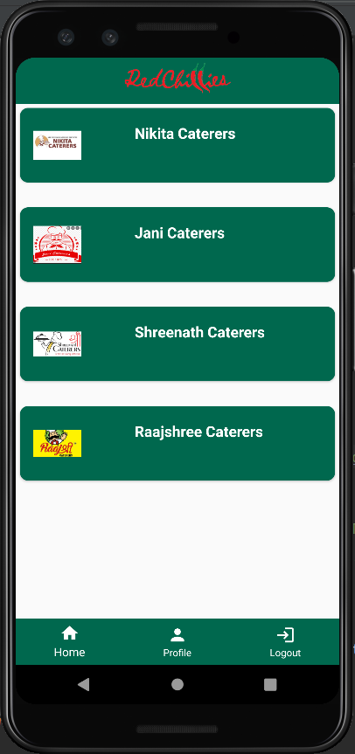

User can see the listed cateres in their homescreen and can select the caterer they want and can view the further details

1. **Caterer Details**

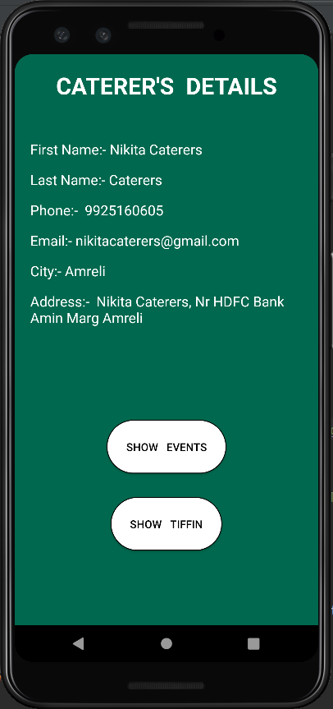

Users can see selected caterer details with option to show events and tiffin offered by that caterer

1. **Show Events**

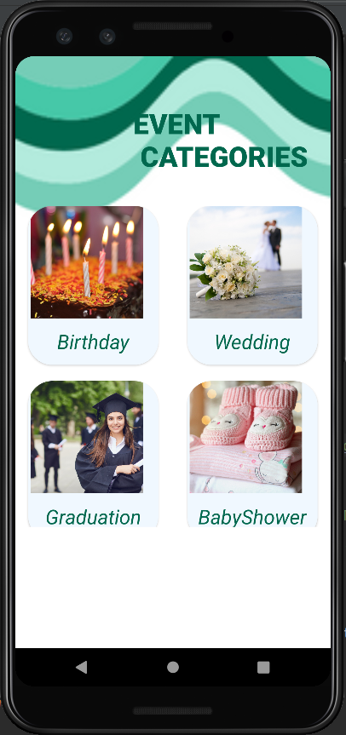

User can choose any event from the listed categories and can further view the packages for the same

1. **Package List**

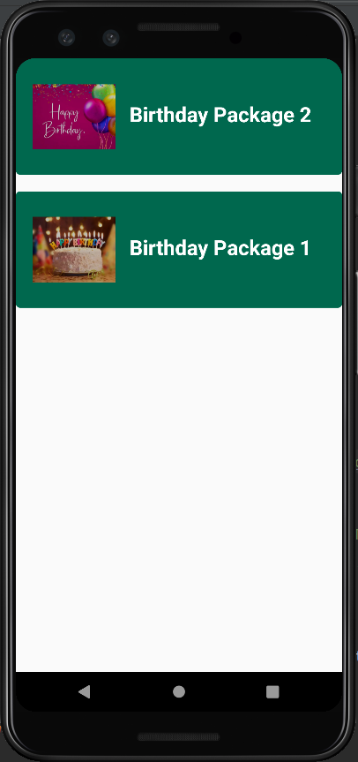

1. **Package Details**

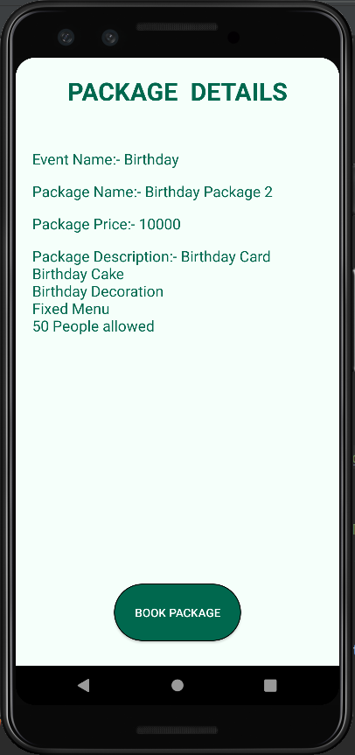

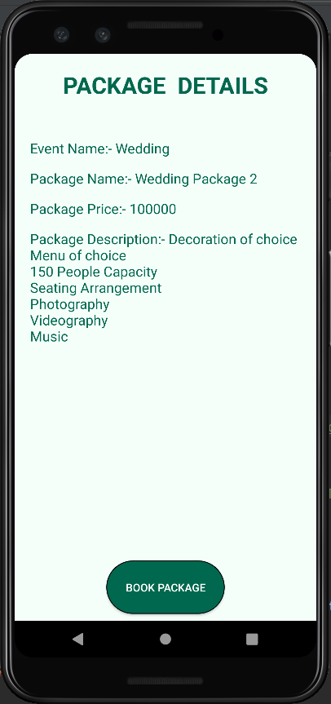

Users can see the package details for the selected event and can book the one with suitable requirements

1. **Show Tiffin**

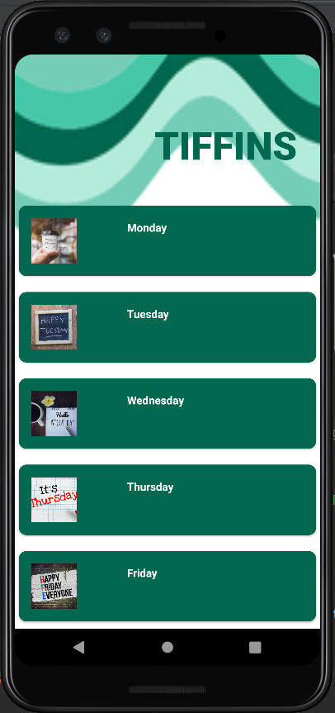

User can select the preferred day of ordering a tiffin and can further view the available tiffins and its details

1. **Tiffin Types**

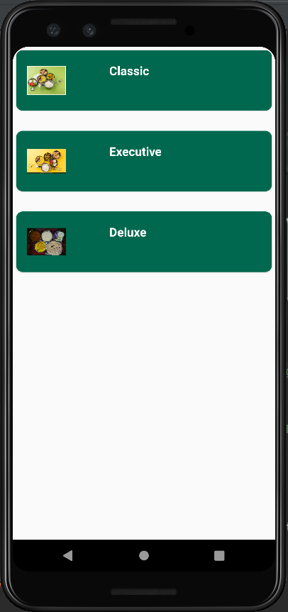

1. **Tiffin Details**

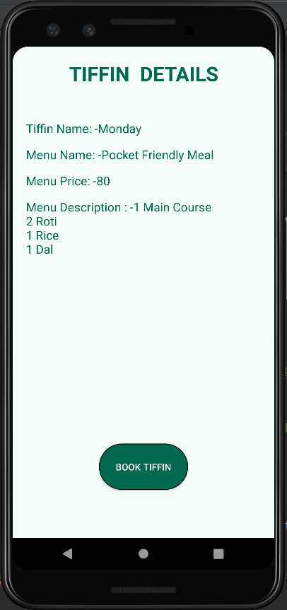

User can select the tiffin type and can view the tiffin details and menu and can book it

1. **Book Tiffin**

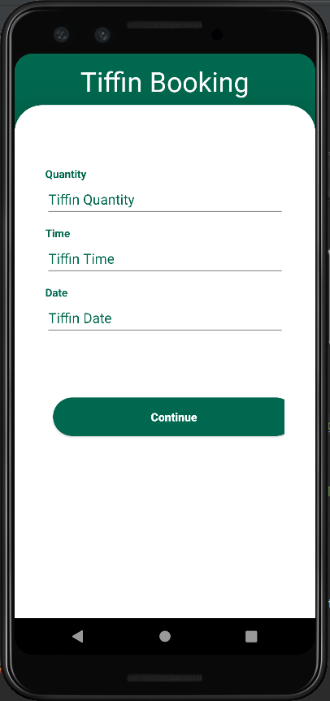

1. **Tiffin Order Details**

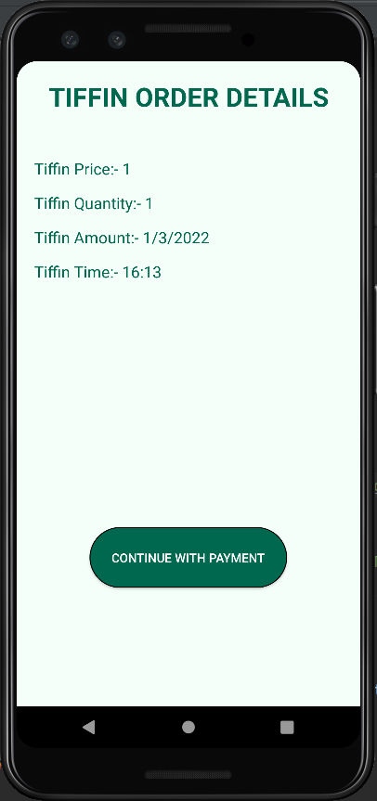

User can view the booking details and can continue with payment to confirm the booking

1. **Payment Screen**

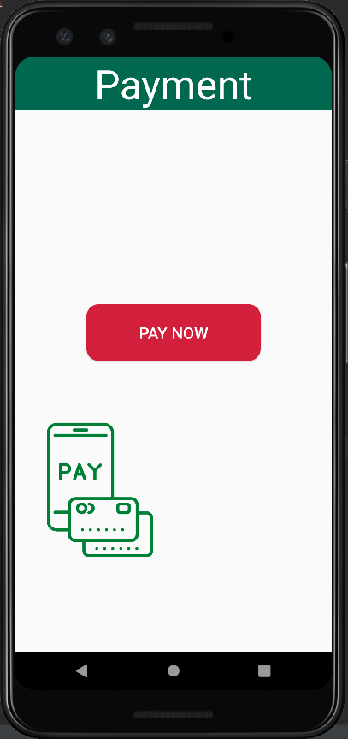

1. **Rate Us Screen**

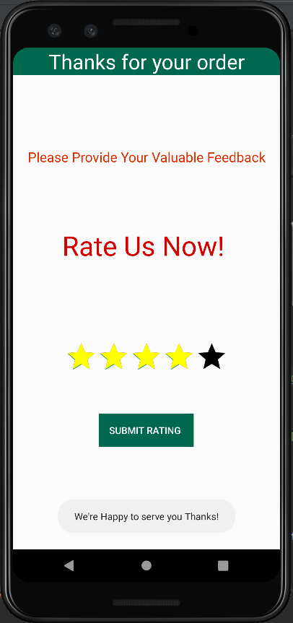

Users can rate their experience and can provide their rating through rating the caterers out of 5

1. **User Profile**

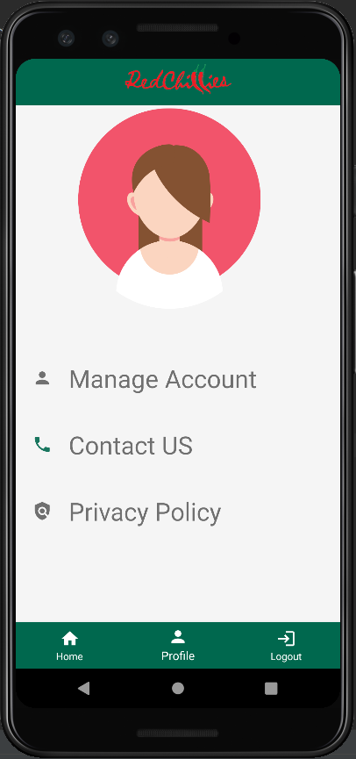

1. **Update User Details**

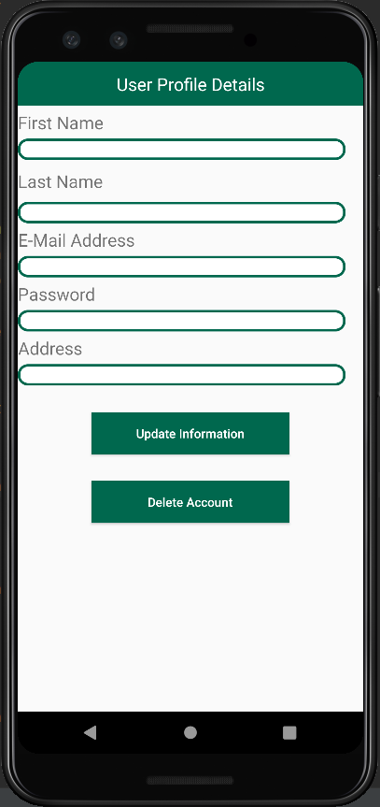

User can update or delete their details by selecting the manage account in the profile section

**28.Privacy Policy Screen**

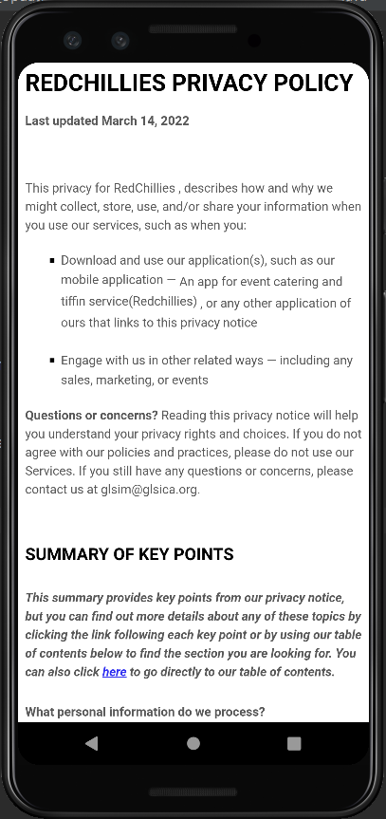

1. **User Sign-out**

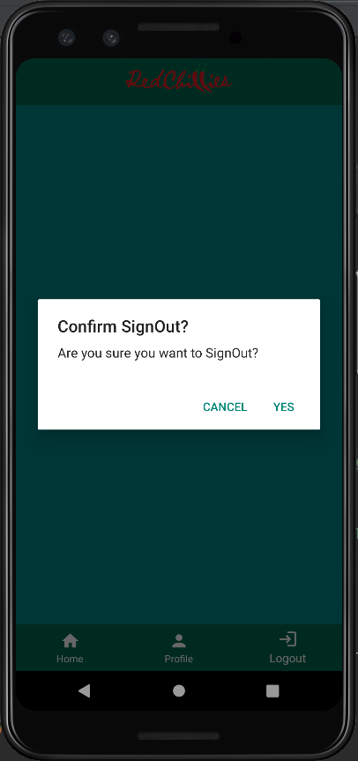

**Realtime Database (Firebase)**

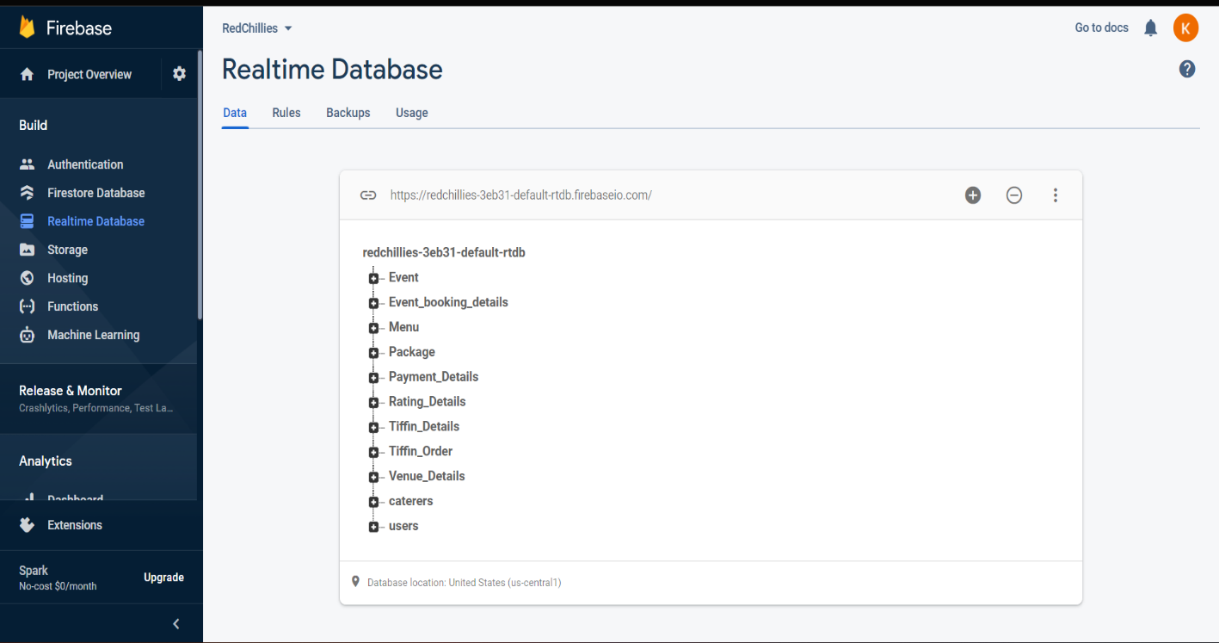

**Admin Panel Screenshots**

1. **Users Table**

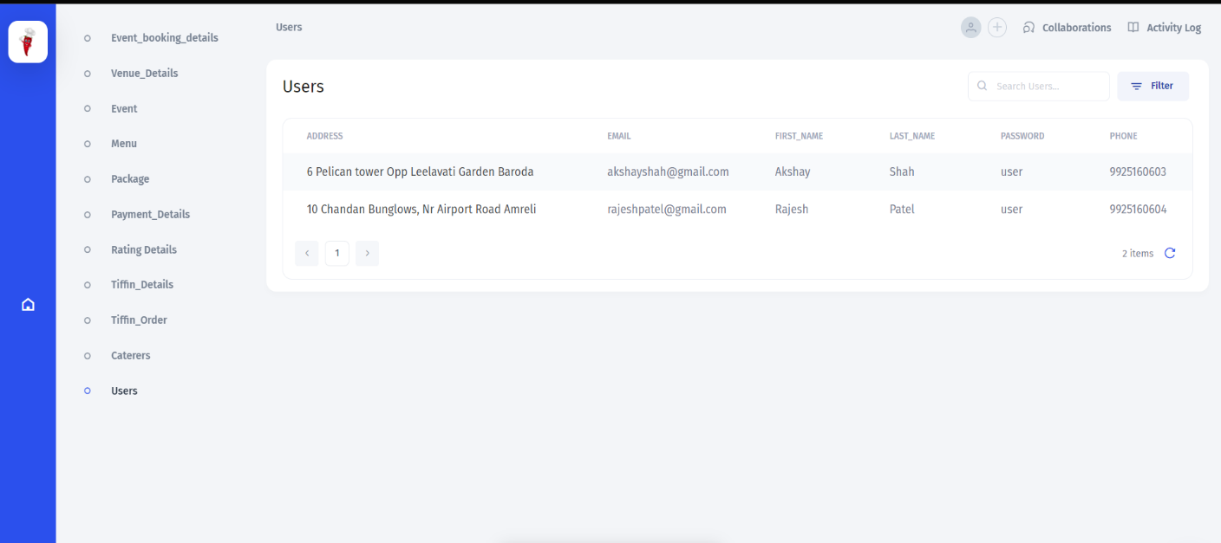

1. **Caterers Table**

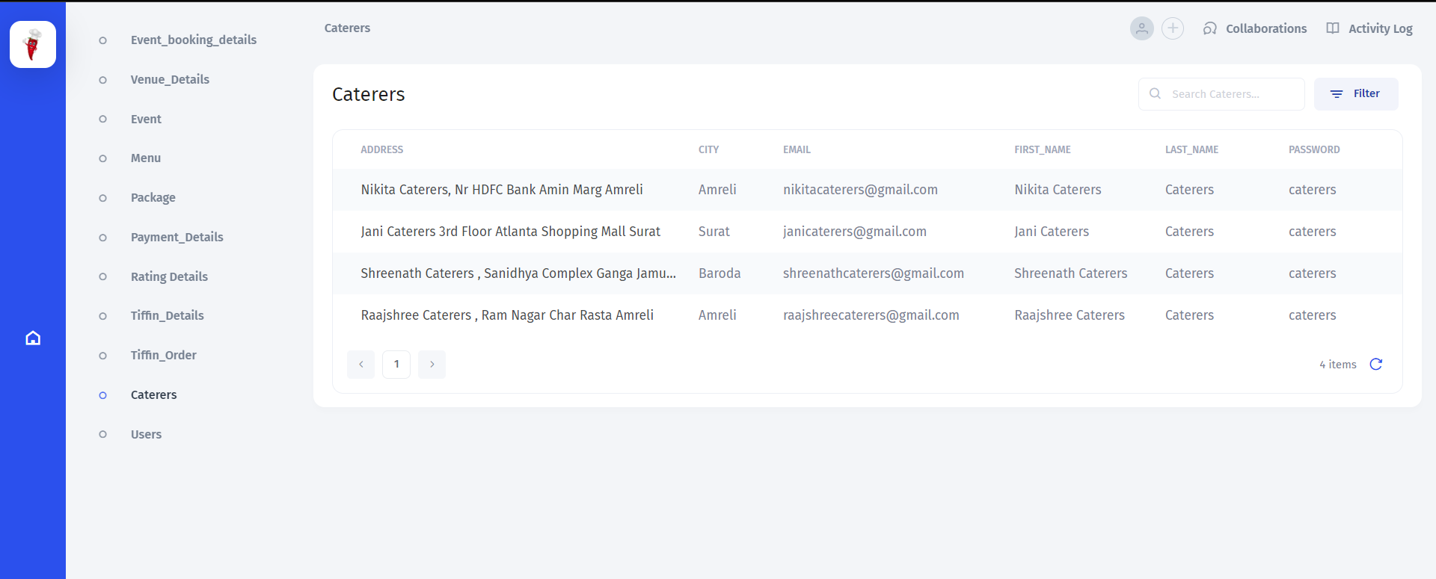

1. **Events Table**

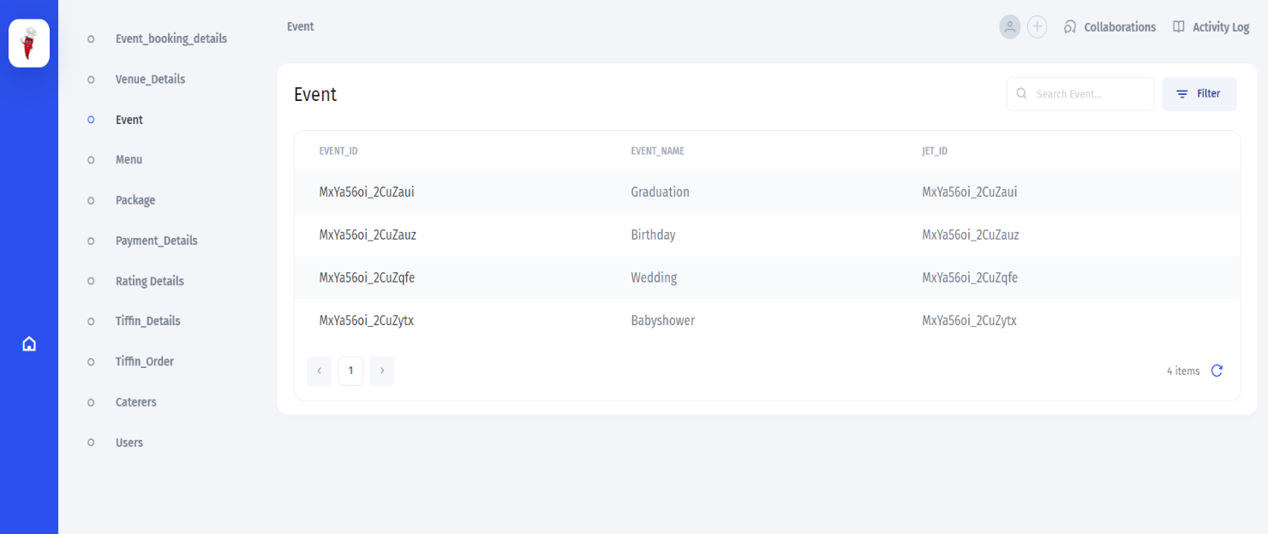

1. **Event_booking_details Table**

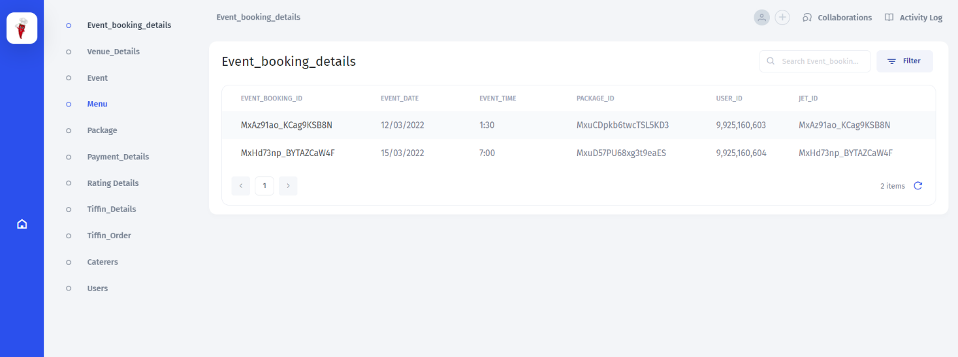

1. **Packages Table**

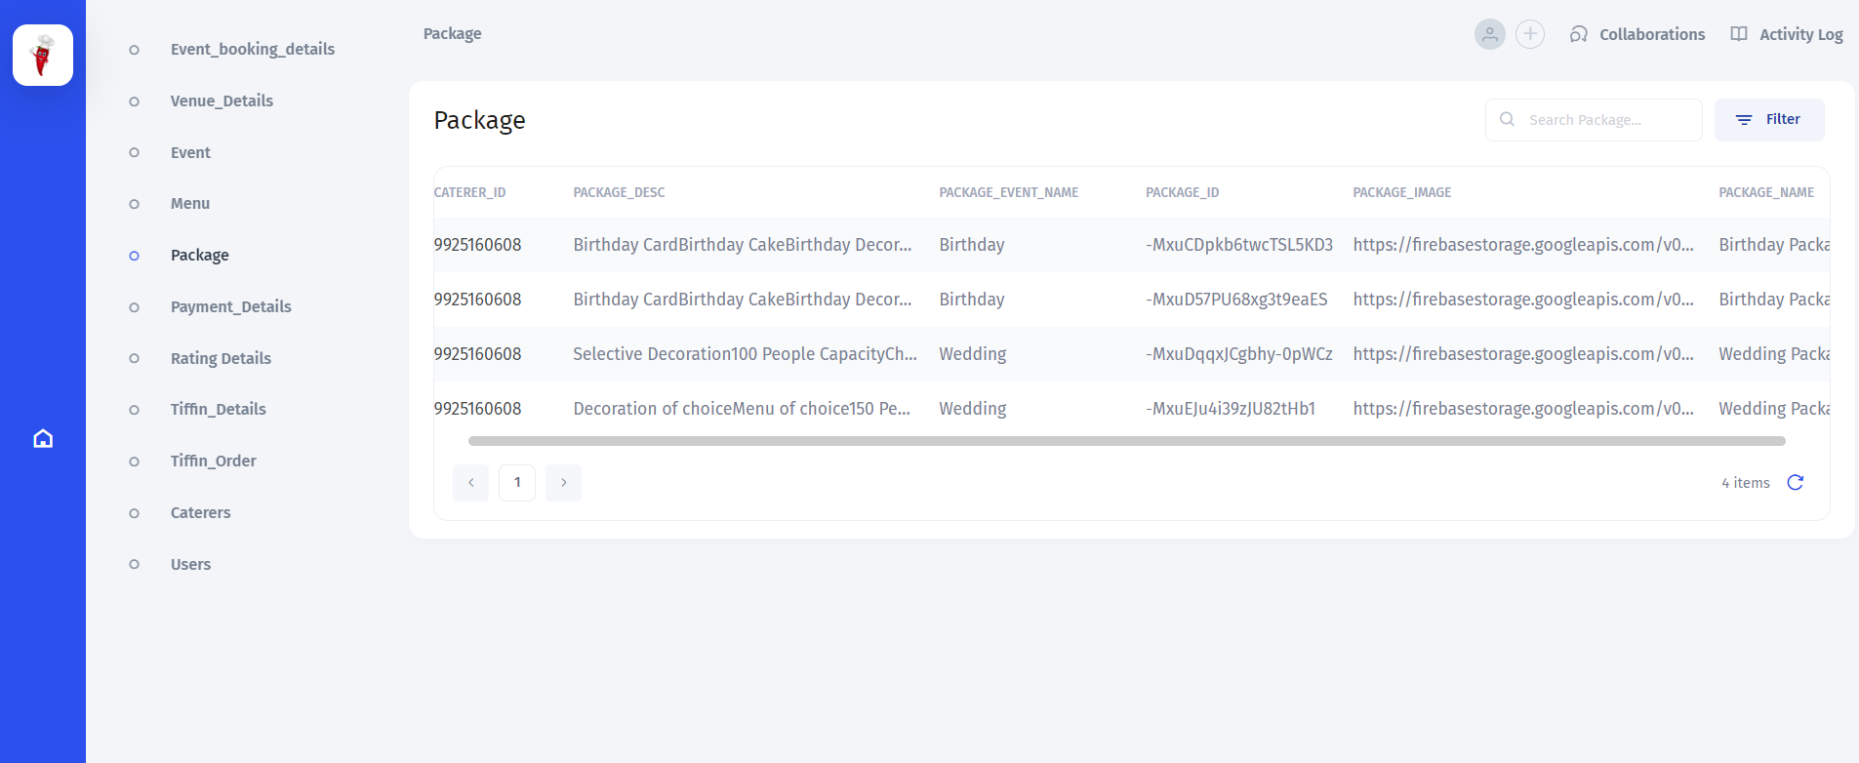

1. **Venue Details**

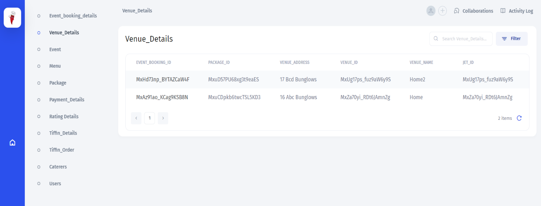

**7. Tiffin_Details Table**

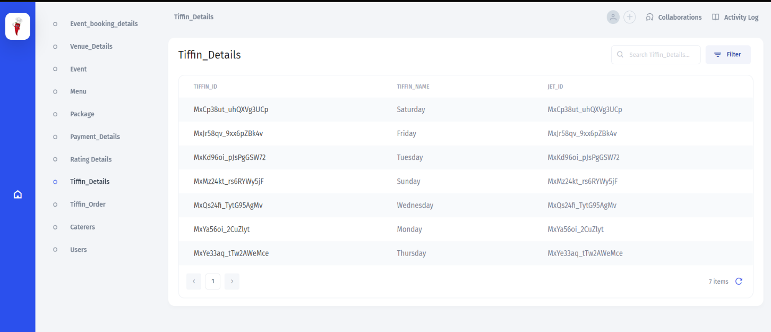

**8.Menu Table**

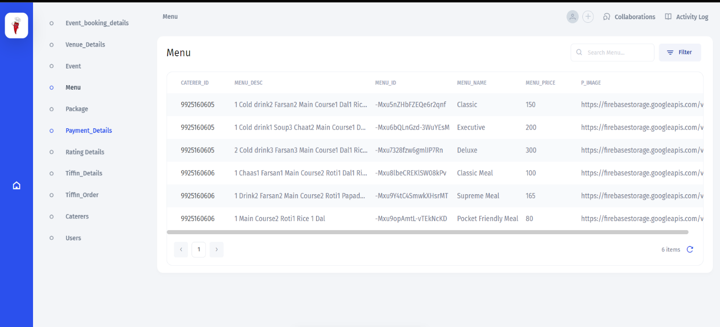

**9. Tiffin_Order Table**

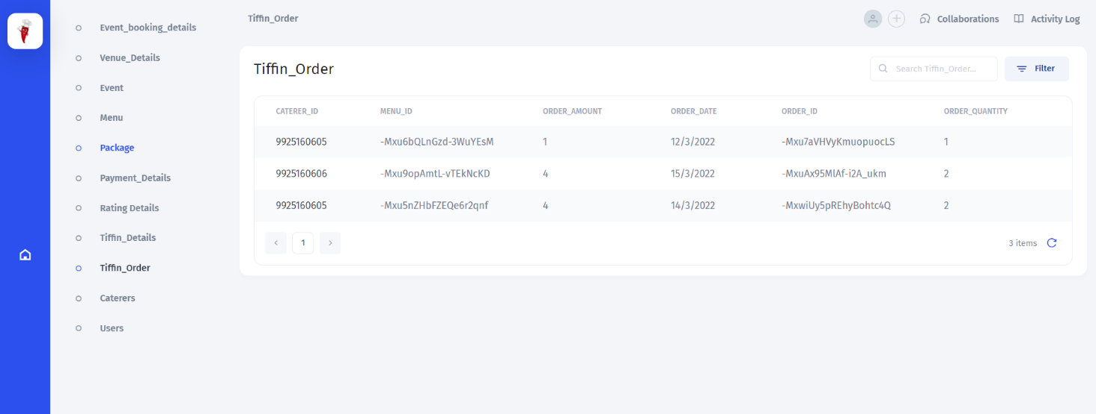

**10.Payment_Details Table**

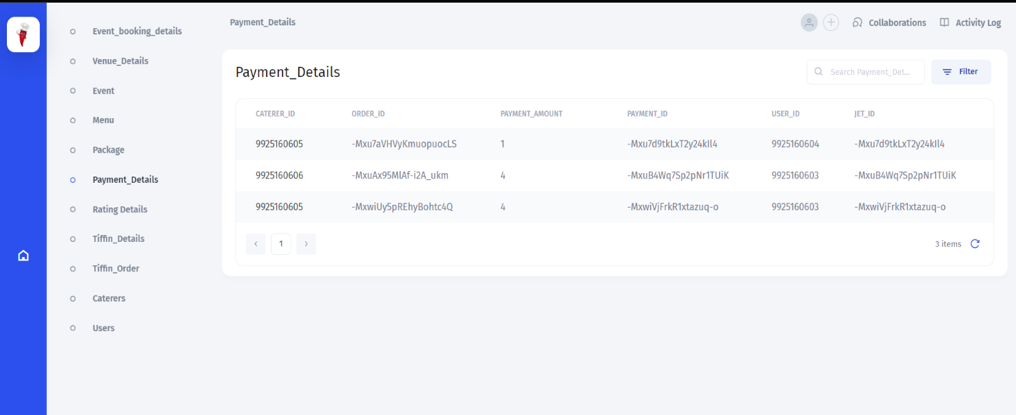

**11.Rating_Details Table**

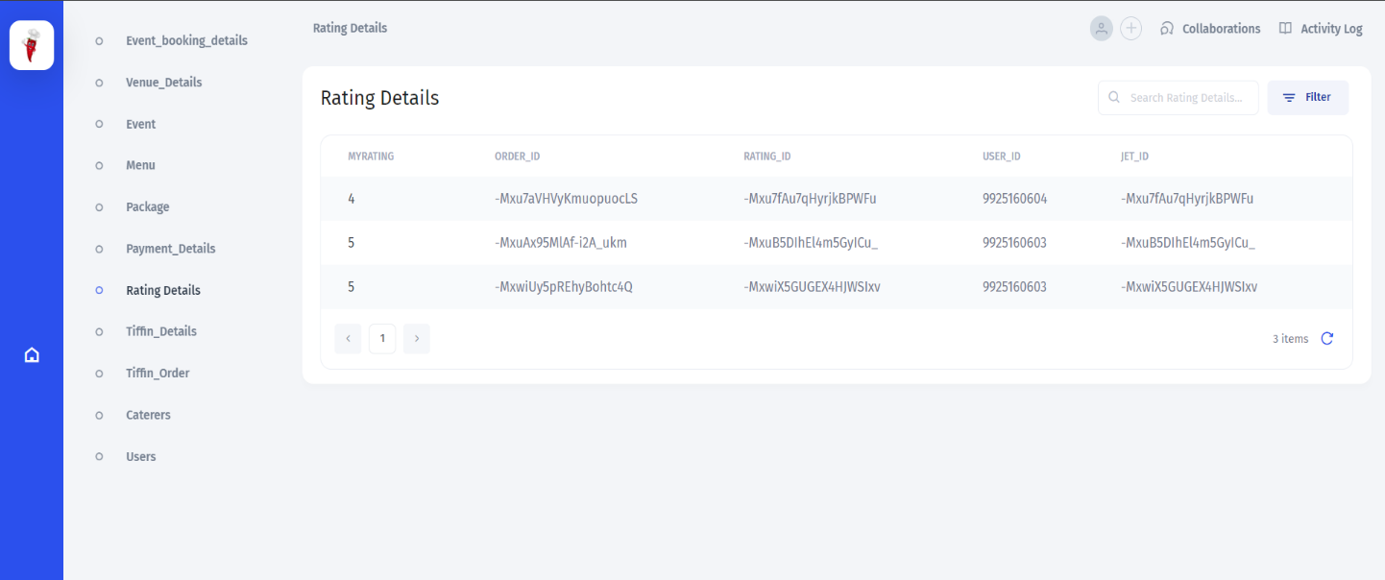

**Conclusion**

We conclude that we enjoyed very much working on the project **“RedChillies- An App for Event Catering and Tiffin Services”** our internal guide **Prof. Ankita Kanojiya** helped us a lot in improving the quality of our project. We have learned many new things from this project although developing this project was a big challenge for us.

This is just the stepping stone for project development there is new paths to be discovered and there are new goals that are to be achieved.

**Bibliography**

<https://app.diagrams.net/> (draw.io) – For UML Diagrams

www.youtube.com/watch?v=mXjZQX3UzOs&t=32386s – For Android Tutorial Videos

[www.canva.com](http://www.canva.com) – For In-app Images and Graphics

[www.github.com](http://www.github.com) – For project references

www.geeksforgeeks.org/android-tutorial/ – For project references

[www.stackoverflow.com](http://www.stackoverflow.com) - For project references